AMMAN ARAB UNIVERSITY
جامعة عمان العربـيــــــة
College of Computer Sciences and Informatics
كلية العلوم الحاسوبية والمعلوماتية


Book Worm Store
Students

Ruba Nassar | ID 202120449
Mohammad Mansour  Mera Ismail Alkhatib | ID 202120304  ID 202110078

Contents
- problem statement
- Business case
- Scope
- Goals
- Project Planning
- Requirement Gathering
- Agile SDLC Model
- UI Mockups
- System Architecture
- Class Diagrams
- Design Patterns
- ER Diagram

List Of Figures and Tables
- Tables
- Table 1 : Shows tools and tech Stacks used

- Figures
- Figure 1 : shows main page of website
- Figure 2 : shows checkout page
- Figure 3 : shows React Classes/Components
- Figure 4: shows Data Classes / Firebase Models

- Problem Statement
Most book lovers are confronted with difficulty in getting an affordable and well-structured online bookstore that has a large stock of titles and an easy purchasing process. Small publishing houses and independent authors also encounter difficulty in promoting their books on established sites. Thus, there is a demand for a simplified and easy-to-use e-commerce website that will provide ease for users to browse, search, and buy books and offer control to administrators over book inventory and store management.

- Business Case
The Book Worm Store hopes to bridge the gap between buyers and sellers of books by offering a user-friendly, basic e-commerce website. It provides:

- A single combined shopping and browsing experience for readers.
- A backend admin dashboard for managing books, authors, and stock.
- A marketplace where small publishers and writers can showcase their books.
- A digital-first approach to providing books to users anywhere, at any time. This website aims to generate revenue through direct book sales, potential subscriptions, and sponsored book promotions.

- Scope
The Book Worm Store will carry:
✅ User Features:
- Book browsing with filters, search, and categories.
- Book details page with descriptions, reviews, and prices.
- Secure checkout procedure with multiple payment options.
- Authentication of users to handle orders and Wishlist.

✅ Admin Features:
- Dashboard to manage book inventory.
- Ability to insert, modify, and delete books.
- Order and customer management.
- Analytics for sales tracking.

❌ Out of Scope (Future Improvements):
- Audiobooks and e-books integration.
- AI-based book recommendations.
- Loyalty programs and individualized discounts.

- Goals
📌 For Users:
- Provide an easy and engaging online purchasing experience.
- Provide fast and convenient access to a large library of books.
- Offer a secure and reliable purchasing process.

📌 For Admins:
- Enable easy book management and inventory tracking.
- Provide an efficient means of tracking orders and sales.
- Improve store performance with data-backed decisions.

📌Overall
- Develop a viable and scalable online bookstore.
- Offer high performance and usability by providing a clean UI. Create a foundation that can expand with future developments.

- Project Planning

Phases & Key Tasks :

📌 1. Requirements & Analysis (Week 1)

- Identify functional and non-functional requirements.
- Collect UI inspiration and draw wireframes.
- Define tech stack (React, Firebase, etc.).

📌 2. Design (Week 2)
- Design UI in Figma (User + Admin).
- Complete color scheme, typography, and UX flow.
- Develop responsive prototypes.

📌 3. Frontend Development (Week 3-4)
- Deploy user interface (React + Vite).
- Book listing, book details, cart, and checkout.
- Admin panel: add/edit/delete books.

📌 4. Backend & Integration (Week 4-5)
- Integrate Firebase (Firestore DB, Auth, Storage).
- Implement authentication (users + admins).
- Manage book CRUD and orders.

📌 5. Testing & QA (Week 5)
- Test all functionality (manual + automated).
- Bug fixing and UI improvements.

📌 6. Deployment & Final Review (Week 6)
- Deploy to Firebase Hosting or Vercel.
- Final user acceptance testing (UAT).
- Documentation & project delivery.

- Requirement Gathering

🔹 1. Stakeholders
- End Users: Those people who visit and purchase books.
- Admin: Responsible for book inventory and content.
- Developer : Constructs and sustains the system.

🔹 2. Functional Requirements
🛒 User-Side (Frontend)
- FR1 : See list of available books.
- FR2 : Search/filter books by category, author, title.
- FR3 : See book details (image, description, price, etc.).
- FR4 : Add books to cart.
- FR5 : Remove books from cart.
- FR6 : View cart contents.
- FR7 : Checkout (no real payment integration available).
🔐 Authentication
- FR8 : User registration and login.
- FR9 : Guest checkout or browse without login.

🧑‍💼 Admin Panel
- FR10 : Login as admin.
- FR11 : See list of all books.
- FR12 : Add new books (with picture, details, price).
- FR13 : Edit published books.
- FR14 : Remove books.
📦 Database / Backend (Firebase)
- FR15 : Store book information (Firestore).
- FR16 : Store images (Firebase Storage).
- FR17 : User/admin authentication (Firebase Auth).

🔹 3. Non-Functional Requirements
- Responsive desktop, tablet, and mobile design.
- Quick load time (optimize images, Firebase queries).
- Secure access to admin panel.
- Intuitive UI/UX (created using Figma).
- Real-time updates (optional Firebase listeners).
- Scalable Firebase structure for growing data.

🔹 4. Tools & Tech Stack
Table 1 : Shows tools and tech Stacks used
Layer | Tool
Frontend | React + Vite
UI Design | Figma
Backend | Firebase (Auth, Firestore, Storage)
Deployment | Vercel or Firebase Hosting
State Mgmt | React Context or Redux
Version Ctrl | GitHub

🔷 Chosen Model: Agile SDLC Model
Agile is iterative, quick, and perfect when requirements can be changed midway through development — something that happens often in frontend/backend-intensive projects such as this one.

🔹 1. Requirement Gathering
- Determine admin and user requirements.
- Collect functional and non-functional requirements.
- Requirement Specification Document (prepared in the earlier step).
🔹 2. Planning
- Define feature sprints and timeline.
- Delegate tasks and timelines (refer to Gantt chart available on GitHub ).
- Tools: Gantt Online, GitHub Projects, Notion.

🔹 3. Design
- UI/UX designing in Figma.
- System design (backend Firebase, frontend React).
- Plan a responsive layout.
- Design Database schema (Firestore collections: books, users, cart).
🔹 4. Development
- Sprint 1: Setup React + Firebase, basic routing, homepage.
- Sprint 2: Book listing, details, and cart functionality.
- Sprint 3: Admin panel CRUD for books.
- Sprint 4: Authentication , cleanup, testing.
🔹 5. Testing
- Manual testing of all features (add to cart, admin functionality).
- Bug fixing sprint after each major feature.
- Responsive testing on devices.
- Firebase security rules testing (admin-only access)
🔹 6. Deployment
- Frontend: Vercel or Firebase Hosting.
- Database: Firestore setup live.
- Domain : Configure a custom domain.

🔹 7. Maintenance & Updates
- Track issues.
- Add new features (e.g., wish list, ratings, orders).
- Firebase billing and quota management if scaled.

- UI Mockups



Figure 1 : shows main page of website

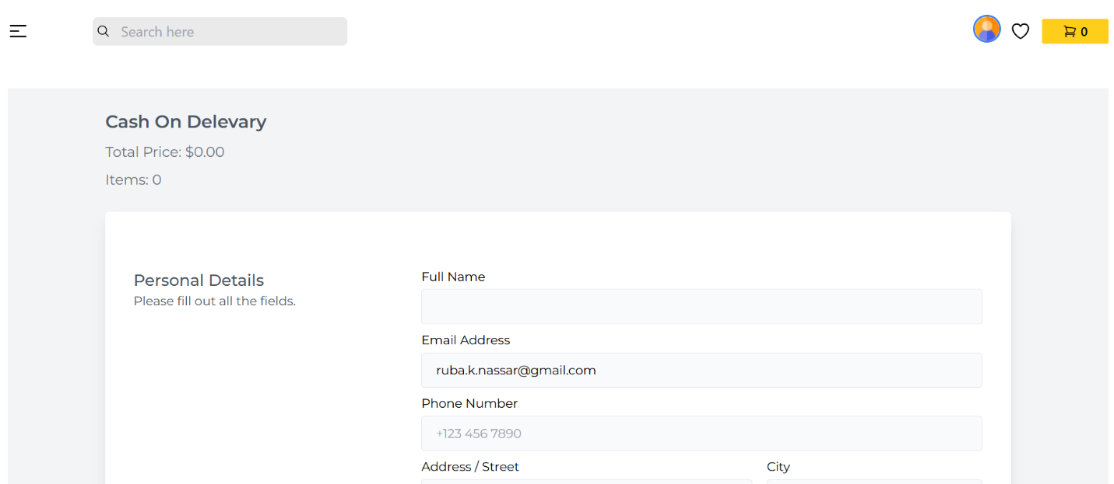

Figure 2 : shows checkout page

- System Architecture
📐 Modified MVC/Component-based Architecture:
- Model: Firebase Firestore, Authentication, Storage — holds app data (books, users, cart).
- View: React components – displays UI.
- Controller/Logic: React hooks (e.g., useEffect, context), Firebase API calls (CRUD).
🔹 Technologies:
- React (View + Controller)
- Firebase (Model)
- Firestore collections: books, users, cart

X. Class Diagrams
- Frontend (React Classes/Components)
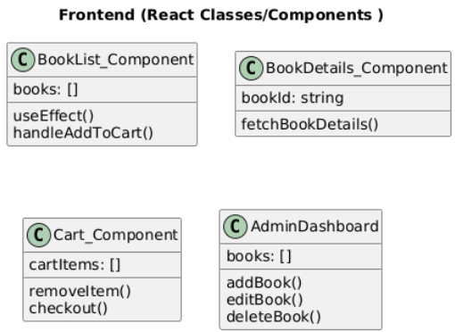

Figure 3 : shows React Classes/Components

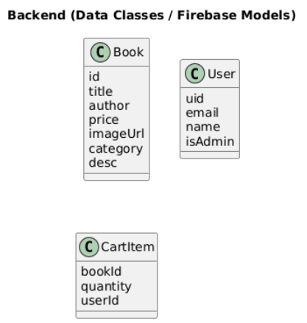
- Backend (Data Classes / Firebase Models)

Figure 4: shows Data Classes / Firebase Models

XI. Design Patterns

🔸 1. Component Pattern – React-based
Each piece of UI is modular.

Promotes reusability (e.g., BookCard, CartItem, etc.)

🔸 2. Singleton Pattern – Firebase Initialization
Firebase instance is initialized once and reused across app.

🔸 3. Observer Pattern – Firebase real-time updates
Components react to Firestore document changes using listeners.

XII. ER Diagram
Entities:
- Book
- User

Relationships:
- A User can have many CartItems
- A CartItem contains 1 Book
- An Admin is a special User (can be represented by a flag)

